Shopping Cart Project

The shopping cart project is an e-commerce application, which is the latest trend to do sales on Internet. In this project one has to develop windows which guide the shopper to shop from your site. The shopper can see items from various available categories along with their price for shopping and add it to there basket(here we will call it as cart). The total value for the items is displayed for the shopper whenever they want. Once the shopper decides to buy the items selected by them, They are prompted for the shopper information. On filling all the required information a thank you window appears. An option is provided for the shopper to add or delete items from the shopping cart whenever he/she decides prior to order placement only.

PS: Two windows are provided for displaying the available items. One with the dropdown list box and other without drop down list box , both having full details about the items.

All the windows in this standalone application will be prepared using HTML, CSS.

Following is the description of various windows which need to be created for this application

Welcome Window:

This is an initial window which welcomes a shopper to shop from this site

Execute the application program to open this window .
Clicking on the link Shop takes the shopper to the Select Category Window.

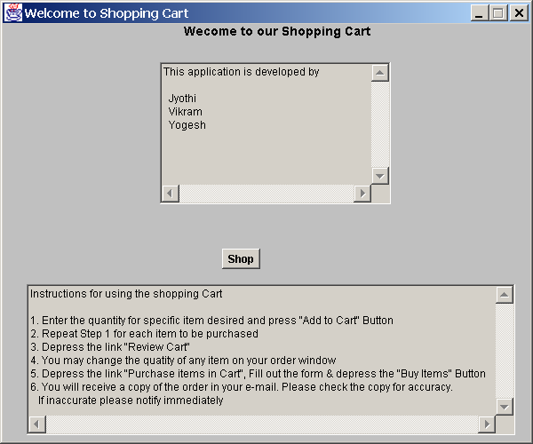

Select Category Window:

This Window gives the shopper the information about various categories of items available in the Shopping Cart. The shopper can choose any particular category.
After choosing any one of the category say Ornaments, it will take the shopper either to a Simple catalog window or a catalog with drop down Menu window depending upon his choice made in the options available.

There are 4 kinds of links in this window:

Items link : It includes various categories like Ornaments, Books, Computers, etc. and on choosing any one of them, the shopper will be taken to the catalog window based on the choice made in options available(simple or with drop down Menu).
Note: On selecting a particular category ( search is made to the array) and all items belonging to the Item category is displayed in the next window.

Shop : It takes the shopper to the View Shopping Cart Window.

Two Options are available for the user
- Simple Catalog
- Catalog with Drop down Menu
Clicking on any one of these 2 links will take the shopper the corresponding window.

Home : Will take the Shopper to the Welcome window(i.e. is the Initial Screen).

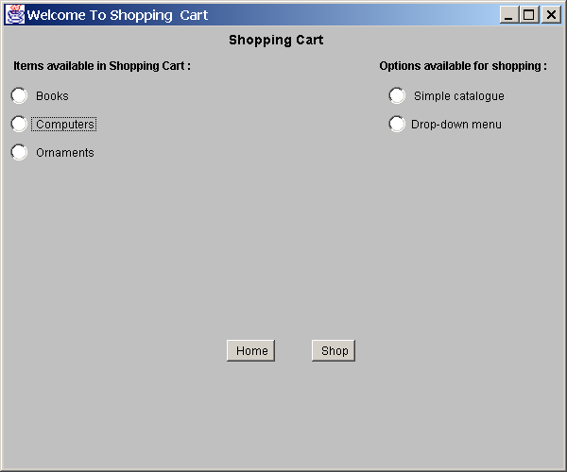

Simple Catalog Window

In this window list of all available items belonging to this item category appears along with the price.

If the shopper wishes to buy more than one item, then for every item he needs to enter the quantity & click the respective ‘Add To Cart’ button

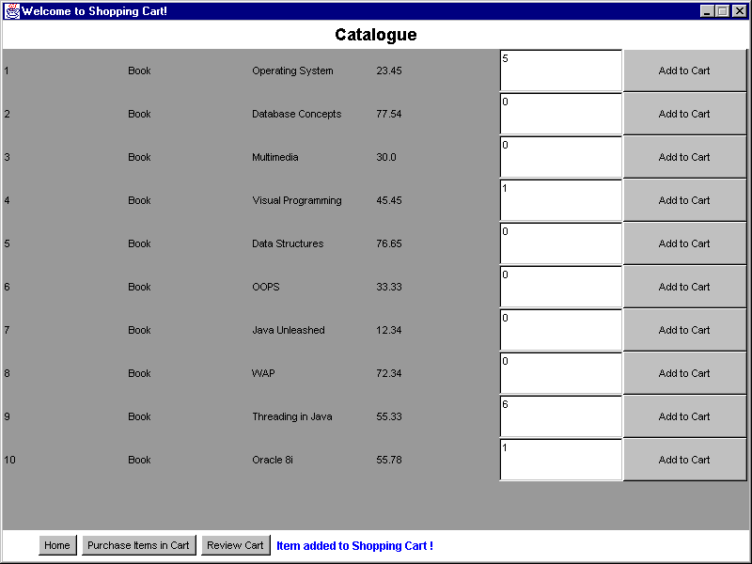

Note:
- When the quantity chosen is less than or equal to zero & ‘Add to Cart’ button is clicked, an error message should pop up & display “ Item Not added to the Shopping Cart”.

- Item name, price & quantity selected by the shopper should be stored in an array.

There are 3 links in this window
- Review Cart : Which will take the shopper to another window ,which displays the entire selected items with the name , quantity & price.
- Purchase items in Cart : Will take the shopper to the Purchase Order window
- Home: Already Described

Catalog with dropdown Menu :

In this window a list of all available items, belonging to the Selected item category, are populated in the drop down list. The shopper will select one item and its price will be displayed. He/She has to enter the quantity and click ‘Add To Cart’ button to select that item for his/her cart

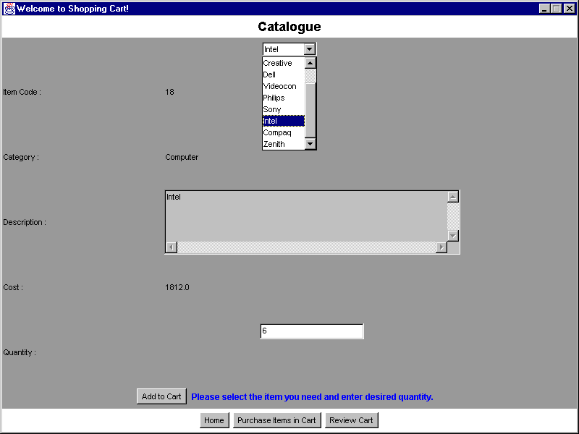

There are 3 links in this window which are already explained.

View Shopping Cart Window:

This window will show the shopper all the items which has been selected for his/her cart.

If the shopper desires to change the quantity of selected item , then he/she can change the quantity text field & click on the ‘Re-calculate’ button.

In this Window there are 3 links in this window which are already explained

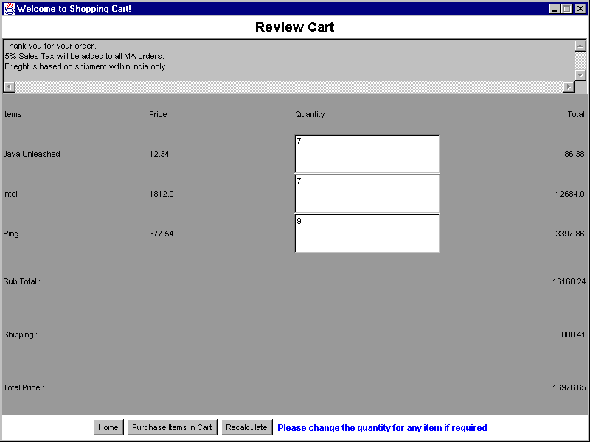

Purchase Order Window:
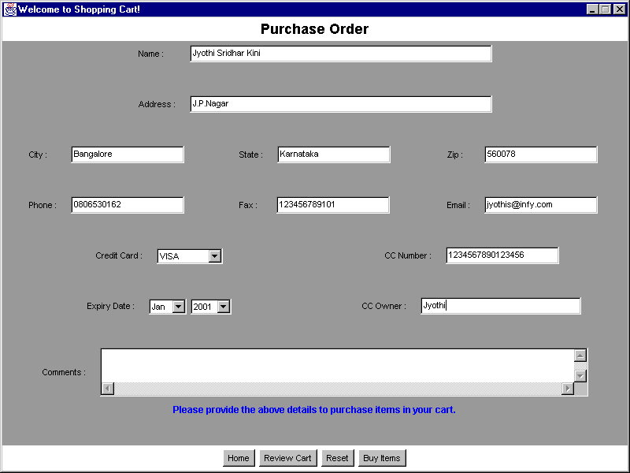

This window is used to place the order for all the items chosen by the shopper. The shopper has to give his/her personal details like name, email-id, address and also credit card details.

Note:
- In this window any blank fields should be checked. Credit Card validation should be done for appropriate Credit Card Number, which would have been already stored in an array.
- On entering valid data and clicking on ‘Buy items’ button, the shopper is taken to the Thank You window
- Clicking on the Reset Form should reset the values entered by the shopper to blank.
- Error message should pop up if any of the text field is left blank.

Thank You Window:

This window contains one link:
Exit: This will stop the application

